Software Construction and Development
Chapter 1
Software Construction
- It is the process of creating a working and useful software by writing code, checking it carefully, and testing it (unit testing).
- It is not just simply changing a design into code. It also involves solving problems and handling important technical challenges.
- It requires clear communication between the programmer and the computer — the programmer must give clear and correct instructions because the computer follows instructions exactly and does not understand mistakes.
Software Construction – Issue Dialog
1. Communication Between Human and Computer
Software construction requires a clear communication (dialog) between the programmer and the computer.
2. Computer’s Limitations
The computer cannot understand unclear meanings or incomplete instructions.
It only follows exact and clearly written commands.
3. Developer’s Responsibility
Developers must be logical, careful, and precise so that the computer can correctly understand their instructions.
4. Strengths of Both Sides
This relationship works because both humans and computers have different strengths.
5. Computer’s Strengths
- High accuracy
- Strong memory (retention)
- Very fast performance once instructions are clear
6. Human’s Strengths
- Creativity
- Problem-solving ability
- Ability to clearly explain solutions so the computer can execute them correctly
Software Construction Related to Software Design
1. Close Relationship
Software construction and software design are closely connected.
2. What Software Design Does
Software design studies the software requirements and creates a plan for how the system will be organized and structured.
This plan becomes the base for building the software.
3. Breaking Big Problems into Small Parts
Design methods divide a big problem into smaller and simpler parts.
This process continues until each part is small enough for one developer to handle easily and confidently.
4. When Construction Begins
Software construction usually starts after the design has divided the large problem into manageable pieces.

5. Key Difference
- Software construction produces working, executable software.
- Software design, however, mainly creates plans and structure and may not produce any working software directly.
Boundary Between Software Construction And Software Design
- Boundary is not always clearly defined.
The line between designing the software and actually building it is often blurred, because sometimes design and coding happen together.
- Small projects may skip formal design.
In small projects, developers may start coding without creating detailed design documents.
- Large projects need interaction between design and construction.
In large projects, design and coding must work together and influence each other.
- Design techniques also apply during construction.
Developers often continue using design methods while writing the code.
- Design involves approximations that may need correction later.
Design plans are not always perfect and may need changes during the coding process.
Different Emphasis – Design and Construction
- Design focuses on partitioning complex problems.
Design is about breaking a big problem into smaller, manageable parts.
- Construction focuses on creating executable solutions.
Construction is about writing code to make the software actually work.
- Well-defined construction tasks should be automated.
Tasks that are clear and repetitive can be done by tools instead of manually.
- Automation trend started with compilers and continues today.
Using tools to automate coding and building started with compilers and is still widely used now.
Traditional Software Development as Large as Life
Traditional software development depends on programmers writing detailed instructions and logic for each part of the software.
Because everything is carefully planned and written, the Software Development Life Cycle (SDLC) is predictable and stable, meaning the steps from start to finish are clear and reliable.
Stage 1: Discovery Phase
- The project team meets with customers and stakeholders to understand what the software should do.
- Developers write down business goals, target users, industry trends, and problems that need solving.
- Main deliverable: A detailed requirements document.
Pros:
- All important project information is collected in one place.
Cons:
- Takes a lot of time to create.
- Information may be wrong or incomplete due to miscommunication.
- Changes in requirements or market trends can cause extra work and major updates.
Stage 2: Design
- Software engineers plan how the software will be structured and how its parts will work together.
- Tools like UML diagrams and modeling tools are used to show the design visually.
Pros:
- Provides a clear blueprint for the product.
- Connects the problems with the solutions.
- Makes the design easy to understand, change, and reuse.
Cons:
- Needs a lot of planning at the start.
- Hard to change later in the project.
Stage 4: Testing
QA specialists (testers) check the software using different tests like user acceptance, integration, unit, compatibility, and accessibility to make sure it works smoothly and has no bugs.
Pros:
- Very accurate in finding issues.
- Shows the real user experience.
- Does not need advanced technical skills.
- Helps find visual problems easily.
Cons:
- Takes a lot of time and effort.
- Can slow down the project if not automated.
Stage 5: Deployment
The finished software is set up and released so users can start using it. This includes preparing the environment, packaging the software, and handing it over.
Pros:
- You can watch the software work in real time.
- Helps follow rules and regulations.
- Can deal with difficult problems carefully.
Cons:
- Needs good planning and teamwork.
- Mistakes can easily happen if not done carefully.
Stage 6: Maintenance
The support team keeps the software running smoothly by updating features, fixing bugs, checking security, and improving performance.
Pros:
- Each problem is fixed separately.
- Every issue gets a solution made for that problem.
- Keeps the software working well for everyone.
Cons:
- Needs continuous effort.
- Can be expensive.
- Uses a lot of resources (time, money, and staff).
Ai-Fueled Software Development Dissected
- Unlike traditional programming, where developers write clear and fixed instructions, AI tools can learn from data and make decisions on their own without being told every step.
- In normal development, programmers write code to directly perform a task. But with AI, developers create systems that learn how to perform the task by themselves.
- Because of this, using AI in software development can make the Software Development Life Cycle (SDLC) faster and easier.
- Another advantage is that AI tools can be used at any stage of software development, such as planning, design, coding, testing, or maintenance.
Stage 1: Discovery Phase (AI-Based)
The project team uses AI tools (like NLP) to understand customer opinions and requirements.
The system automatically creates the first version of the project specifications.
Pros:
- Takes less time.
- Reduces miscommunication.
- Provides a strong and accurate starting point for the SDLC.
Cons:
- Natural language can be unclear or confusing, so AI must carefully handle vague, incomplete, or subjective information.

Stage 2: Design (AI-Based)
- AI tools create the system structure and design documents using the project requirements.
Pros:
- Makes routine design work much faster.
- Helps create quick prototypes (early versions of the software).
- Easily adjusts to changes in requirements.
Cons:
- May reduce designers’ creativity, because AI handles much of the design work.
Stage 3: Implementation (AI-Based)
- Developers use AI coding tools that can predict code, suggest lines, and automate repetitive tasks.
Pros:
- Allows non-technical people to build simple apps (no-code/low-code).
- Increases team productivity.
- Improves code quality with smart suggestions.
- AI models can improve over time.
- Makes team collaboration easier.
Cons:
- Code can be hard to understand sometimes.
- May have security risks.
- Raises ethical concerns (like data use and originality).

Efficient AI Coding Tools in Software Development
- Support developers during coding.
AI tools help programmers at every step of writing code.
- Automatically write and fix code.
They suggest code, complete lines, and help debug errors.
- Improve code reviews.
They reduce human mistakes and make checking code more accurate.
- Give real-time corrections and improvements.
They provide auto-completion, suggest better solutions, and optimize code while you type.
- Find security problems and bugs.
They help detect weaknesses and errors more effectively.
Examples of AI Coding Tools:
Metatable, Tabnine, GitHub Copilot, AskCodi, SQL.AI, SonarQube, Mintlify, Adrenaline AI, Safurai, CodeGPT.
Stage 4: Testing (AI-Based)
QA experts use AI testing tools that automatically create test cases and find possible bugs.
Pros:
- Finds and fixes bugs faster.
- Tests more parts of the software (better coverage).
- Detects bugs more accurately.
Cons:
- May depend on extra tools or layers (wrappers) to work properly.
- Can become unstable if the user interface (UI) changes.
Stage 5. Deployment
AI deployment tools make it simple to set up environments and release software automatically.
Pros:
- Keeps things consistent across deployments
- Fewer mistakes when launching
- Faster release of new updates
Cons:
- Less human checking of the process
Stage 6. Maintenance
AI keeps an eye on how the software is working and suggests fixes before problems happen.
Pros:
- Less time with the system down
- Software works more reliably
- Costs for maintenance are lower
Cons:
- Needs good quality data to work well
- Can miss things humans would notice
Evolution Of AI
AI has grown step by step over time:
- First, deep learning and neural networks helped researchers make smarter AI systems.
- Then, with Big Data and better neural networks, machine learning became possible, letting computers learn from lots of data.
- After that, AI applications started appearing, like text-to-speech, translation tools, computer vision, and virtual assistants.
- Today, AI can drive cars, design posters, and write content. Tools like ChatGPT and DALL-E make AI easy to use for everyday people.
Types Of AI
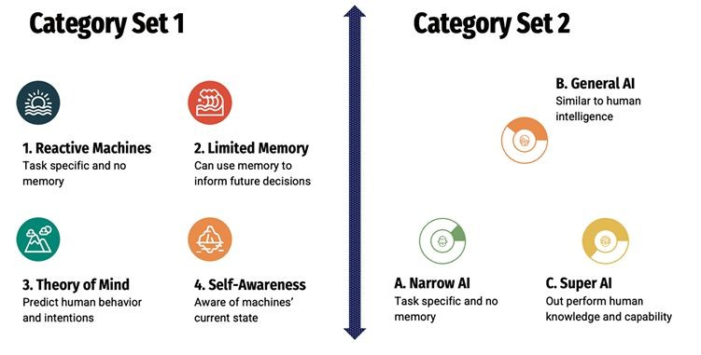

Types of Artificial Intelligence (AI)
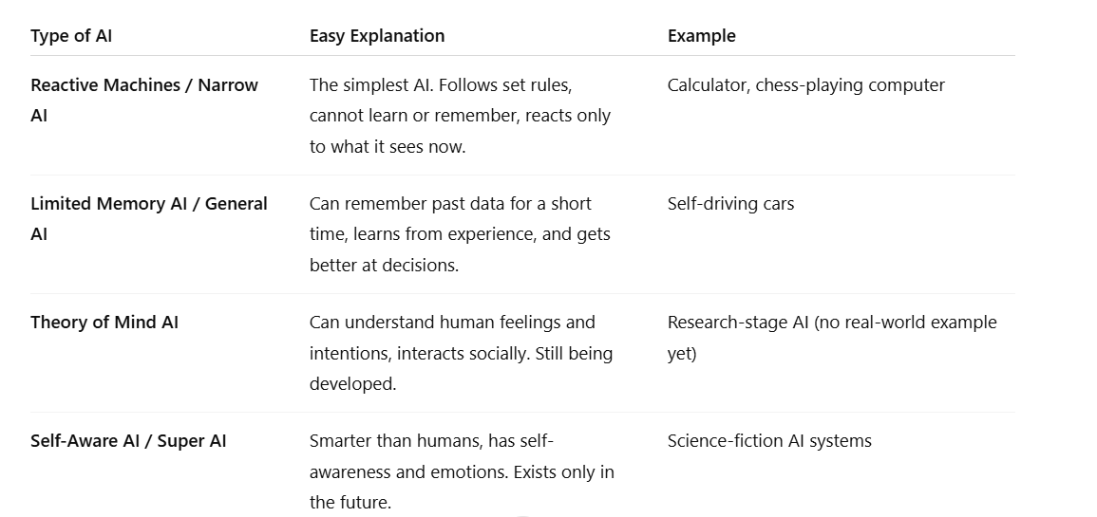
How Does Ai/Ml Work?
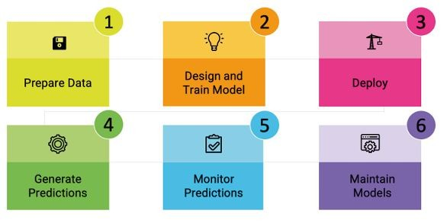

AI Development Lifecycle
Prepare Data
- Gather the right and accurate data
- Remove mistakes, duplicates, and unnecessary parts
- Change data into a format that AI can understand
- Example: Clean pictures of different car models
Design and Train Model
- Choose the best algorithms and tools
- Teach the model using labeled data
- Test the model to make sure it learned correctly
- Tools: TensorFlow, PyTorch
Deploy
- Launch the AI model so it can be used in real life
- Make it available for people or other systems to use
Generate Predictions
- Give the trained model real or live data
- Model looks at the data and gives results
- Example: Recognizing car models from images
Monitor Predictions
- Keep checking if the model’s results are accurate
- Find mistakes or unexpected inputs
- Make sure the model works well with real-world data
Maintain Models
- Improve the model using feedback
- Retrain it with new or updated data
- Fix problems and make it perform better
Benefits of AI/ML
Why businesses use AI:
- Companies can’t just save money by moving work overseas
- IT is now an important part of running a business, not just support
- Businesses want to work faster, save money, and do things better
- AI helps them run smoothly and save time
- Many companies and schools are investing in AI
AI for better decisions:
- Huge amounts of data are created every day
- People can’t check all this data quickly or correctly
- AI can look at the data fast and give smart advice
- Example: AI helps stock traders study data, news, and performance to make better choices
AI and Unstructured Data
- Most data today is unstructured, like images, videos, audio, and text
- Old rule-based systems can’t handle this well
- AI can find useful information from unstructured data
- Example: AI reads social media posts to see what people think about a brand
AI for Speed, Automation, and Personalization
- Markets change fast, so businesses need to adapt quickly
- AI speeds up software development (e.g., GitHub Copilot)
- AI helps give personalized services to each customer
- AI + ML study user behavior, history, and preferences
- AI replaces old rule-based systems with smart automation
- Robotic Process Automation (RPA) makes business processes faster and better
Chapter 2
Construct of AI and ML
- Artificial Intelligence (AI) is a technology that enables machines to perform tasks that normally require human intelligence, such as decision-making and prediction.
- Machine Learning (ML) is a part of AI that allows machines to learn from data and improve their performance through experience.
- Data for learning is often collected from public sources using spider crawlers (like Google crawlers). ML helps AI continuously update its knowledge and produce better results over time.
Role of Data in AI & ML
- Data helps AI learn faster.
- Web crawlers (like search engine crawlers) collect public data from the internet.
- Big data is important for developing and training AI systems.
- Clean and well-organized data improves AI accuracy.
- Using data, machines find patterns and predict future results.
The Structure
ML is a subset of AI.
ML is a continuous learning process
Learning models include:
- Deep Learning
- Computer Vision
- Reinforcement Learning
Generative AI produces:
- Text
- Images
- Videos
- Audio
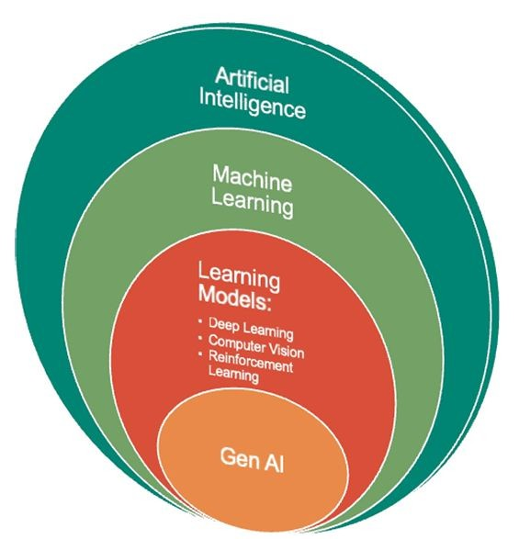

Types Of Machine Learning
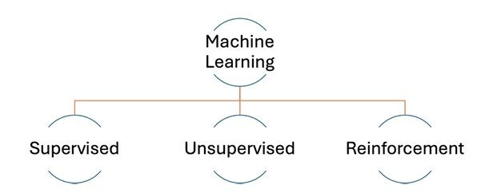
Supervised Learning
- Supervised learning is a method where machines learn using labeled data.
- Each input has a correct output, so the model learns from these input–output pairs.
- The machine studies these examples and learns how to connect inputs with the correct results. After training, it can give accurate predictions for new data.
- Example: In image classification, a machine is trained with labeled images of cats and dogs. After learning their features, it can correctly identify new images.
Unsupervised Learning
- Unsupervised learning uses data that has no labels or answers.
- The machine is not told what the correct output should be.
- The algorithm analyzes the data and discovers patterns on its own.
- It learns without direct instructions or guidance.
- Common tasks include: Grouping similar data (clustering), Reducing data size (dimensionality reduction)
- Example: Shopping Recommendations
Online shopping websites use unsupervised learning.
The system observes what products you view and buy.
It finds patterns in your interests and behavior.
Based on those patterns, it suggests similar or related products.
Reinforcement Learning
Reinforcement learning is a type of machine learning.
In this method, the machine (called an agent) learns by interacting with its environment.
It learns by trying different actions and seeing the results (trial and error).
The agent receives: Rewards for correct actions and Penalties for wrong actions.
These rewards and penalties help the machine improve its decisions.
The main goal is to learn the best action to take over time.
Example: Chess Game
A machine learns to play chess using reinforcement learning.
It receives a reward when it makes a good move.
It receives a penalty when it makes a bad move.
Over time, it learns which moves are better.
The learning continues as it keeps playing and interacting with the game.
Applications Of ML
- Machine learning is mostly used in areas where decisions depend on data analysis.
- It can analyze very large amounts of data quickly.
- This helps organizations choose the best action or solution.
- It works similar to how good leaders study data before making decisions.
Examples of ML Applications:
- Shopping and Content Recommendations
Websites suggest products, movies, or videos based on what users like or search for.
- Medical Image Analysis
Machine learning helps doctors read X-rays, ECGs, and MRIs to detect diseases more easily.
- Finance and Investment
ML helps banks and financial companies analyze markets, detect fraud, and make investment decisions.
- Real-time Language Translation
ML can translate spoken language instantly, helping people from different countries communicate easily.
- Skill Assessment and Training
Companies use ML to analyze people’s skills and create personalized training programs.
Challenges and Future
- Requires large amount of clean data
- Complex algorithms
- Needs high computing power
- Future includes more automation and intelligent systems
ML – Limitations
- Cannot think creatively like humans
- Only as good as the data it's trained on
- Can't explain its reasoning well
- Needs lots of data to work well
- Can amplify existing biases in data
- Important: ML is a tool, not magic. It finds patterns but doesn't truly "understand"
Natural Language Processing (NLP)
NLP helps computers understand human language.
“Natural Language” means the way humans normally speak or write, like English or Urdu.
“Processing” means understanding, analyzing, and creating language.
It is like having a smart translator that not only translates words but also understands the meaning, tone, and context of the message.
Everyday NLP Examples
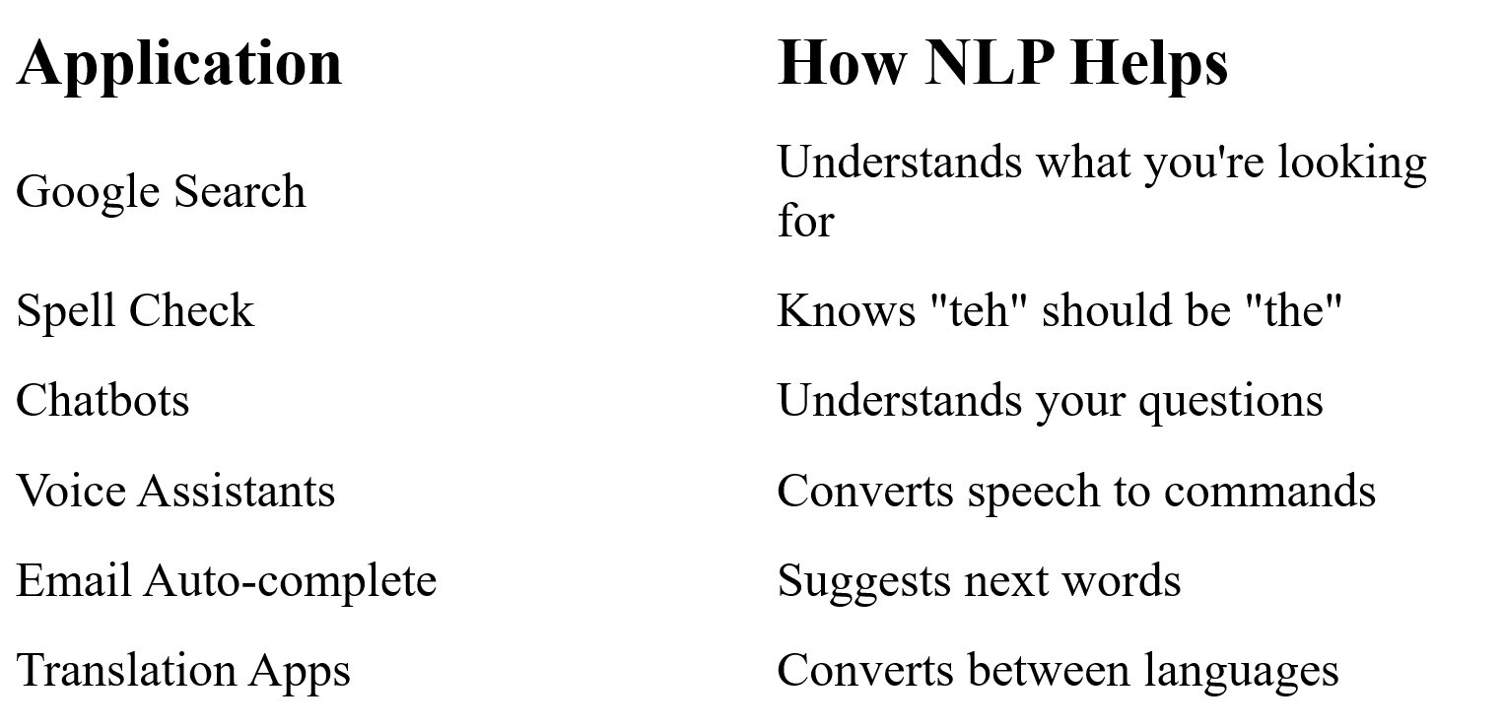

How NLP Works
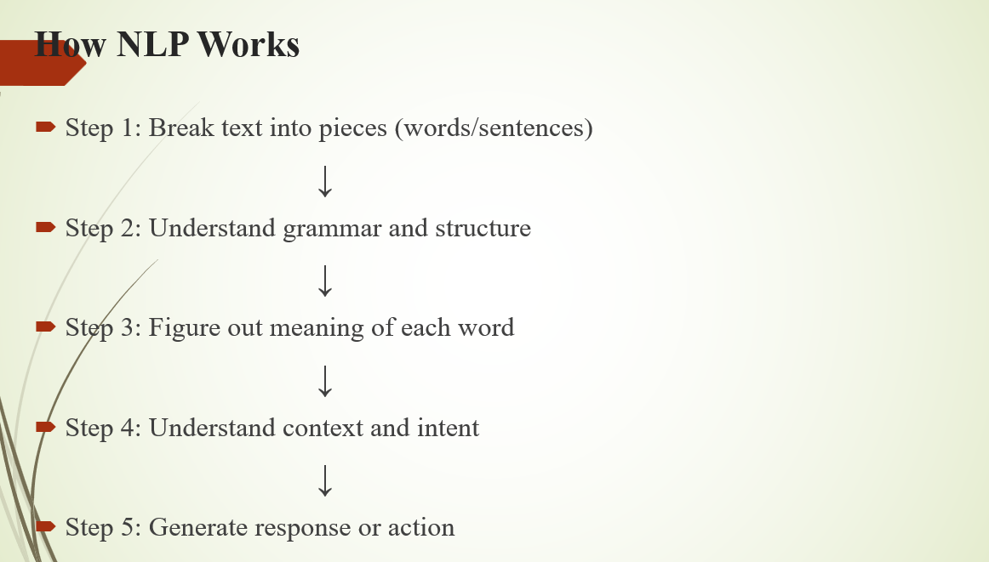

NLP in Software Development
1. Converting Requirements to Code
Developers can write a simple instruction in normal language.
Example:
“Create a login form with email and password.”
NLP tools understand this sentence and can generate a basic code structure for a login form automatically.
This saves time because the developer does not have to write everything from scratch.
2. Code Documentation
NLP can help create automatic comments and explanations for code.
- It reads the code written by the developer.
- Then it generates comments that explain what the code is doing.
Example:
If a function is complicated, NLP can explain it in simple English, making it easier for other developers to understand.
3. Code Search
Normally developers search code using exact keywords.
With NLP, searching becomes meaning-based.
Example:
A developer searches:
“function that calculates tax”
Even if the function name is computeTax(), NLP understands the meaning and finds the correct code.
What is Generative AI?
Generative Artificial Intelligence (Generative AI) is a type of AI that creates new content instead of only analyzing existing information.
“Generative” means:
To produce or create something new.
Think of it like this:
Traditional AI:
“Is this a cat?”
The AI only analyzes and gives an answer (Yes or No).
Generative AI:
“Draw me a cat.”
The AI creates a completely new cat image.
What it can generate:
- Text (essays, emails, code)
- Images (photos, artwork)
- Music and audio
- Video
- 3D models
Large Language Model (LLM)
A Large Language Model (LLM) is an AI system that can understand human language and generate text similar to how humans write.
It does not only understand words, but also:
- Grammar
- Writing style
- Meaning of sentences
- Context (what the conversation is about)
LLMs are trained using very large amounts of text data, such as:
- Books
- Articles
- Websites
During training, the model learns patterns in language using advanced algorithms.
What LLMs Learn
LLMs learn things like:
- Grammar rules – how sentences are formed
- Sentence structure – the correct order of words
- Meaning – what words and sentences represent
- Contextual understanding – understanding the meaning based on the situation or topic
Example:
Tools like ChatGPT use LLMs to understand questions and generate helpful answers.
in easy wording
Main Functions of LLMs
A Large Language Model (LLM) can perform many tasks related to language.
Main Functions
1. Text Generation
LLMs can write new text such as essays, emails, stories, or computer code.
2. Language Translation
They can translate text from one language to another.
Example: English → Urdu.
3. Text Summarization
LLMs can shorten long text and give the main points in a few sentences.
4. Sentiment Analysis
They can identify the feeling or opinion in text, such as whether it is positive, negative, or neutral.
5. Question Answering
LLMs can understand questions and provide answers based on the information they learned.

Example of an LLM
Generative Pre-trained Transformer (GPT) is a well-known type of LLM.
Versions like GPT-2 and GPT-3 are examples.
These models are trained for many days using very large datasets from the internet, which helps them learn how humans write and communicate.
Key Software Construction Principles
Software construction principles are guidelines that help developers build software that is easy to understand, modify, and manage over time.
1. Modularity
Modularity means dividing a software system into small and independent parts called modules.
Each module performs a specific task and communicates with other modules using clear interfaces.
Importance of Modularity
1. Reduces Complexity
Large software is broken into smaller parts, which makes it easier to manage.
2. Easier Development and Understanding
Developers can focus on one module at a time, so the system becomes easier to build and understand.
3. Easy to Modify
If changes are needed, developers can update one module without affecting the others.
4. Supports Team Work
Different teams or developers can work on different modules at the same time, which speeds up development.
2. Readability
Readability means how easy it is for a person to read and understand the software.
Readable software is clear, organized, and follows a logical structure.
Importance of Readability
1. Helps Developers Understand Quickly
Developers can grasp the system faster if the code and design are easy to read.
2. Reduces Errors
When software is clear, it prevents mistakes caused by misunderstandings.
3. Easier Collaboration
Team members can work together smoothly because everyone can understand the code easily.
4. Saves Time
Readable software makes debugging and adding new features faster.
3. Maintainability
Maintainability means how easily software can be changed, updated, or fixed after it is released.
This includes fixing bugs, improving performance, or adding new features.

Importance of Maintainability
1. Extends Software Life
Well-maintained software can be used for a longer time.
2. Reduces Cost and Effort
Easier maintenance saves time, money, and effort.
3. Makes Updates Safer and Faster
Changes can be made quickly without breaking other parts of the software.
4. Keeps Software Useful
Software can adapt to new requirements as needs change.
Chapter 3
Software Development and Ai Augmentation
Why Use AI in SDLC
Improves software development
AI helps make the software development process better and more efficient.
Automates many tasks
AI can automatically perform many development activities, which saves time and effort.
Increases speed and accuracy
AI helps developers work faster and produce more accurate results.
Reduces human errors and manual work
AI decreases mistakes and reduces the amount of repetitive manual work.

DevOps – A Game Changer in SDLC
Automation in development process
DevOps uses automation to make the software development process faster and easier.
Automatic processes
Many tasks run automatically using triggers and predefined rules.
Supports CI and CD
DevOps supports Continuous Integration (CI) and Continuous Delivery (CD), which means code changes are tested and delivered quickly.
Works well with Agile
DevOps works very effectively with Agile methods where development happens in small and frequent updates.
Result: Faster development
Because of automation and continuous processes, software is developed faster and more efficiently.
AI – The Next Transformation in SDLC
Advanced automation
AI takes automation to a higher level and makes software development smarter.
Better project estimation
AI helps developers estimate project time and effort more accurately.
Reduces bugs and maintenance issues
AI helps detect errors early, which reduces bugs and future maintenance problems.
Improves software quality
AI improves the overall quality, performance, and reliability of software.
Goal: Near-perfect systems
The main goal is to build software systems that work very well with very few errors.
Zenith in Efficiency and Productivity (Highest Level of Efficiency)
AI becoming very important in development
AI is becoming a major technology used in software development.
Less manual work for humans
AI automates many development tasks, so developers do less manual work.
Developers focus on important tasks
Because AI handles routine work, developers can focus more on creating and improving features.
Machines handle routine tasks
Repetitive and technical tasks are done automatically by machines.
Examples of tasks AI can automate:
- Code generation – AI can automatically write code.
- Software testing – AI can test software to check if it works correctly.
- Bug fixing – AI can help find and fix errors in the code.
- Software deployment – AI can automatically release software to users.
- Software upgrades and maintenance – AI helps update and maintain software easily.

AI vs Traditional Code Review Tools
Traditional tools (like SonarQube)
Traditional code review tools mainly find bugs and code quality issues in the code.
AI-based tools
AI tools can review code in a more detailed and complete way.
- Faster analysis
AI tools can analyze code much faster than humans.
- Early problem detection
They can find possible problems early in the development process.
- Real-time suggestions
AI tools can suggest improvements while developers are writing code.
Unparalleled Software Quality (Very High Software Quality)
Better predictions using AI
AI improves predictive analysis in software development.
Uses past project data
AI can study data from previous software projects.
Predicts future problems
By analyzing this data, AI can predict possible problems that may happen in the future.
Avoids repeating mistakes
It helps developers learn from past mistakes and avoid repeating them.
Better final product
Because of this, the final software has fewer bugs and defects and better quality.
AI in Software Testing
- Developers can’t test every part of a software manually.
- AI can automatically create many test cases to check the software.
- AI can do regression testing to make sure old features still work after updates.
- AI can also test performance (speed) and security of the software.
- This helps find problems early and makes the software better and more reliable
Regression Testing: Regression testing is a software testing process that ensures recent code changes, such as bug fixes, enhancements, or configuration updates, have not adversely affected existing features.
Faster and More Comprehensive Testing
High-speed testing
- AI can test software very quickly.
Covers more scenarios
- It can check many more cases than manual testing.
Early detection of problems
- AI can find vulnerabilities early in the development process.
Fix problems sooner
- Finding problems early helps fix them before software release.
Better software quality
- The result is higher quality and more reliable software.

Advanced Decision Making with AI
Quick data analysis
- AI can analyze large amounts of data very fast.
Understands patterns
- It can find patterns and important information in the data.
Better decision making
- AI helps make smarter decisions based on the analysis.
Helps stakeholders
Makes it easier to plan and manage projects, such as:
- Program planning – deciding what work to do and when
- Resource allocation – managing people, time, and money
- Risk management – identifying and handling possible problems
AI in Feature Prioritization
Challenge in development
- It’s hard to decide which features to develop first.
AI helps by
- Analyzing user requirements – understanding what users want
- Prioritizing important features – deciding which features are most important
Better final product
- AI helps make sure the software meets user needs and business goals

AI Provides Cost Savings and Resource Management
Goal of companies
- Companies want to build software at lower cost and more efficiently.
Optimizes resources
AI helps manage resources like:
- Infrastructure – servers, tools, systems
- Human resources – developers, testers, teams
Reduces project costs
- By using resources efficiently, AI lowers overall project costs.
Frees humans for important work
- When AI handles routine tasks, humans can focus on creative and important tasks.
Continuous software development
- Software needs regular maintenance
- New features are added over time
AI Enables Proactive Risk Management
Risks and opportunities
- Risks and opportunities are connected, like threads in a fabric.
- Good leaders can turn risks into opportunities.
AI predicts risks
- AI uses past project data and current plans to predict possible risks.
Early action
- Teams can act early to prevent or reduce risks.
Better project success
- Proactive risk management improves success and reduces problems in projects.
Overview Of AI Infused SDLC
AI can help in every step of making software.
- Planning phase: AI helps guess how long tasks will take and collect what the software needs.
- Design phase: AI helps make designs and predict how the software will work.
- Build phase: AI helps write code and can even create code automatically.
- Testing & Deployment phases: AI can test the software automatically and make the release process smoother.
AI infused SDLC
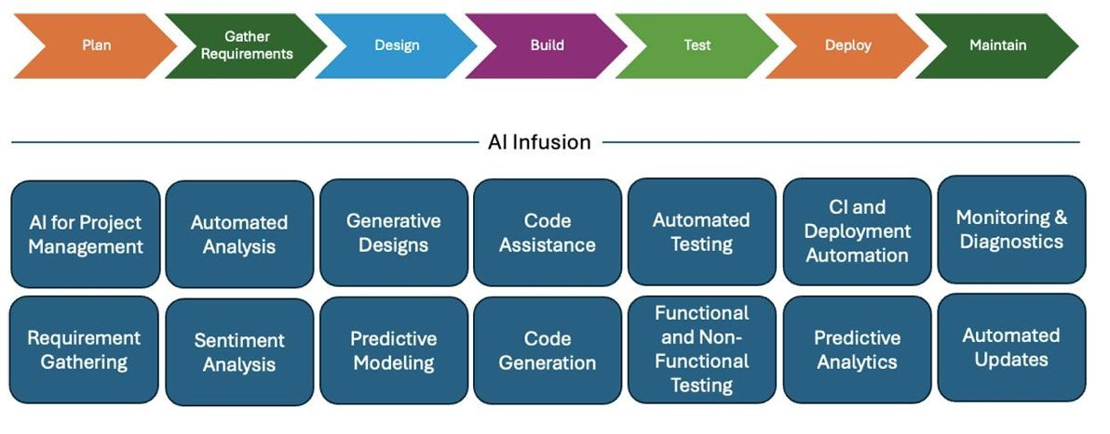

AI Infusion in Planning Phase
AI helps plan software projects better.
- AI guesses how long tasks will take using past project data.
- AI predicts what resources are needed and spots possible risks.
- Natural Language Processing (NLP) reads messages and documents from stakeholders.
- NLP automatically finds and ranks requirements from discussions.
AI Infusion in Requirements Gathering
AI makes collecting software requirements easier and smarter.
- AI checks if requirements match business goals automatically.
- NLP tools review stakeholder feedback and understand their opinions.
- Sentiment analysis helps decide which features are most important to users.
- AI gives useful insights and handles repetitive research tasks automatically.
AI Infusion in Design Phase
AI helps make software design easier and better.
- AI suggests good design ideas from best practices.
- It uses old successful projects as examples.
- It tries different cases to find weak points in the design.
- It helps test designs quickly for small first versions of the software.
AI Infusion in Building Phase
AI helps developers while they are writing code.
- AI pair programmers suggest code pieces to developers.
- AI spots possible bugs during coding.
- AI can review code while developers are writing it.
- AI creates simple repeated code for routine tasks.
AI Infusion in Testing Phase
AI makes software testing faster and smarter.
- AI tools create test cases automatically.
- AI runs tests and finds bugs without humans.
- Machine learning identifies code areas likely to have defects.
- AI helps test things like performance and speed.
- AI reduces bugs in the final software and lowers support costs.
AI In Continuous Integration and Maintenance
AI In Continuous Integration and Deployment
AI makes software deployment faster and safer.
- AI automates the whole CI/CD process.
- AI speeds up build and make deployments more efficient.
- AI manages deployment steps and can roll back automatically if needed.
- AI predicts the best time to deploy based on past data.
- AI reduces downtime and prevents problems for users during deployment.
Challenges of AI in Deployment
Using AI in deployment comes with some problems.
- Relying too much on AI can cause extra challenges.
- AI may not fix problems if it malfunctions.
- AI’s suggested solutions can sometimes be wrong.
- Over-automation can create deployment issues.
- Humans still need to watch and control the process.
AI In Maintenance Phase
AI helps keep software running smoothly after release.
- AI watches software performance in real-time.
- AI quickly finds and diagnoses problems.
- AIOps (AI for IT operations) is used for maintenance effectively.
- AI can apply updates automatically with little human help.
Chapter 4
Integrating AI and LLMs in the Planning Phase
Integrating AI and LLMs in the Planning Phase (Simple Explanation)
- Planning is a very important step in any project.
- It helps the team think about all the work and possible problems before starting.
- Good planning makes the project more successful and reduces risks.
- AI and Large Language Models (LLMs) help make planning easier, faster, and smarter.
Importance of Planning
1. Covers All Work Areas
Planning helps us think about all parts of a project.
2. Prepares for Problems
It prepares the team for different situations before they happen.
3. Better Decision-Making
Planning helps in making better decisions.
4. Proper Use of Resources
It helps use time, money, and people in the right way.
5. Saves Time and Cost
Good planning saves time, money, and effort in the future.
Planning in SDLC Projects
- In Software Development Life Cycle (SDLC), planning is a critical phase.
- Projects include many plans and sub-plans.
- Examples include project plan, risk plan, resource plan, and schedule plan.
- Proper planning ensures smooth software development.
Key Planning Activities
- Project Initiation – Start of the project
- Feasibility Study – Check if project is possible
- Resource Planning – Decide needed resources
- Project Scheduling – Set time and deadlines
- Budgeting – Plan the cost
- Communication Planning – Plan team communication
- Risk Management – Identify and handle risks
- Quality Assurance Planning – Ensure good quality
- AI Support – AI tools help improve all activities
Project Initiation
Project initiation is the first and most important step of the Software Development Life Cycle (SDLC). It is the stage where the project is planned at a basic level before actual work starts.
Every project has three main limits called the triple constraint:
- Scope → what work will be done
- Time → how long the project will take
- Cost → how much money will be needed
AI Integration in Project Initiation
- Define the Project’s Purpose and Scope – AI tools analyze requirements and suggest a clear project scope.
- Identify Stakeholders and Their Expectations – AI can analyze communication and documents to identify stakeholders and their needs.
- Establish Project Objectives and Goals – AI helps generate measurable goals and supports better decision-making.
Feasibility Study
Purpose: Evaluate if a project is possible and worthwhile before starting.
Key Areas of Assessment:
- Technical Feasibility – Can we build it with available technology?
- Operational Feasibility – Will it work smoothly in the organization?
- Economic Feasibility – Are the costs justified by the benefits?
AI Integration:
- Technical: AI predicts risks and technical challenges.
- Operational: AI analyzes workflows and resource allocation.
- Economic: AI estimates costs and ROI for better decision-making.

Resource planning
Resource planning identifies the resources required for the project.
It means we decide what people, tools, money, and systems are needed before starting work.
Key resources:
- Human resources → people like developers, testers, and managers
- Technology and tools → software, computers, and systems
- Budget and infrastructure → money and basic facilities needed to run the project
Main activities:
- Identify required resources → figure out what we need
- Assign roles and responsibilities → decide who will do which task
Role of AI:
- Optimize resource allocation → AI helps assign the right people to the right tasks
- Predict workload distribution → AI estimates how much work each team member will have
- Improve team productivity → AI suggests better ways to work faster and smarter
Project Scheduling
Project scheduling means making a timeline for all project tasks. It tells us what work will be done, when it will start, and when it will finish.

Scheduling includes:
- Task start and end dates → when each task begins and ends
- Task dependencies → which tasks must be completed before others start
- Milestones and deadlines → important points and final due dates in the project
Role of AI:
- Predicts project timelines → AI estimates how long the whole project will take
- Identifies possible delays early → AI warns if something might slow down the project
- Improves accuracy → AI uses past project data to make better schedules
Budgeting
Budgeting means planning and managing the money needed for a project. It makes sure the project is completed without running out of funds.
Main activities:
- Cost estimation → estimating how much money the project will need
- Cost monitoring → continuously checking and controlling spending
Role of AI:
- Uses past data → AI studies previous project costs to help plan better budgets
- Predicts expenses → AI estimates future costs so planning becomes easier
- Improves accuracy → AI makes budgeting more correct using data and patterns
Communication Plan
A communication plan is a system that makes sure everyone involved in the project stays informed and connected. It helps stakeholders share information clearly and on time.
Key activities:
- Establish communication channels → deciding how people will talk (email, meetings, chats, etc.)
- Schedule meetings and updates → planning regular meetings and progress updates
- Share project reports → sending reports so everyone knows project status
Role of AI:
- Automated reporting → AI can automatically create project reports
- Smart notifications → AI sends alerts and reminders to the right people
- AI-generated summaries → AI summarizes project updates in simple form
Risk Management
Risk management means finding problems that might happen in a project and planning how to deal with them. It helps reduce chances of failure.

Steps:
- Identify potential risks → find possible problems (like delays, cost increase, or technical issues)
- Analyze risk impact → check how serious each risk could be
- Develop mitigation strategies → plan solutions to reduce or avoid those risks
Role of AI:
- Predict risks → AI can guess future problems using data
- Analyze patterns → AI studies past projects to find common risk patterns
- Early warnings → AI alerts the team before a problem becomes serious
Quality Assurance Planning
Quality assurance (QA) planning means making sure the project work and final product meet the required quality standards. It focuses on preventing mistakes and improving reliability.
Activities include:
- Defining quality standards → setting rules for what “good quality” means in the project
- Establishing quality control processes → creating steps to check quality during development
- Testing and validation → checking the system to find errors and confirm it works correctly
Role of AI:
- Defect prediction → AI can predict where bugs or errors are likely to happen
- Automated testing → AI runs tests automatically to save time and effort
- Continuous quality monitoring → AI keeps checking the system regularly for issues
AI-Enhanced Agile Estimation Techniques
In Agile development, estimation means predicting how much work a project needs and how long it will take.
It helps decide:
- Project effort → how much work is required
- Development time → how long tasks will take
- Resource requirements → how many people and tools are needed
How AI improves estimation:
- Analyzes historical data → AI studies past projects to make better predictions
- Improves accuracy → AI reduces mistakes in time and effort estimation
- Better decision-making → AI helps teams plan more effectively and choose the best approach
Agile Estimation Techniques
Planning Poker
Planning poker is a team-based technique used in Agile to estimate work (user stories).
How it works:
- Each team member gets cards with numbers (usually Fibonacci numbers like 1, 2, 3, 5, 8, 13, 21, etc.)
- Everyone chooses a card secretly to show how much effort they think the task needs
- All members reveal their cards at the same time
What happens next:
- If estimates are similar, the team agrees easily
- If estimates are very different, the team discusses why they chose those numbers
- After discussion, the team estimates again until they agree (consensus)
Planning Poker Example
Scenario:
We are estimating effort for an AI-based recommendation system feature.
User Story:
“As a user, I want the recommendation system to suggest products based on my purchase history.”
Discussion:
The team talks about possible challenges like:
- Cleaning and preparing data
- Choosing the right AI model
- Connecting the feature with the existing system
Estimation:
- Each team member chooses a card privately
- Everyone shows their cards at the same time
- Estimates may differ (for example: 5, 8, 13)
- The team discusses the differences
- After discussion, they agree on a final estimate (for example: 8)
Process Steps:
- Product owner reads the user story
- Team selects estimation cards privately
- All cards are revealed together
- Team discusses differences in estimates
- Final agreement (consensus) is made
- Repeat if needed for better accuracy
Role of AI:
- Analyzes past sprint data → AI looks at old project work to help make better guesses
- Suggests story points → AI gives helpful ideas about how much effort a task may need
- Finds estimation gaps → AI shows where team members have very different opinions in estimates
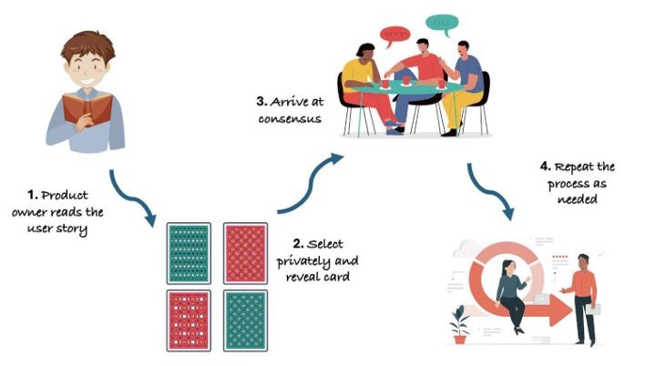
T-Shirt Size Estimation
T-shirt size estimation is a simple way to estimate work in projects. Instead of numbers, we use sizes like:
XS, S, M, L, XL
These sizes show how big or difficult a task is based on:
- effort needed
- time required
- complexity of the work
Example (AI Chatbot Project):
- Small (S) → Simple task
Adding basic keyword recognition
- Medium (M) → Moderate task
Building an NLP model to understand user intent
- Large (L) → Difficult task
Connecting chatbot with external API for real-time data
- Extra Large (XL) → Very complex task
Building an advanced AI chatbot that handles complex conversations and context
Role of AI:
- Analyzes code complexity → checks how difficult the task is
- Suggests size automatically → recommends XS, S, M, L, or XL
- Improves accuracy over time → learns from past projects to give better estimates


Dot Voting
Dot voting is a simple team method to decide which tasks are most important.
How it works:
- A list of tasks or features is given
- Each team member gets a few “dots” (votes)
- They place dots on the tasks they think are most important
- The task with the most dots wins
Simple Example:
AI-based fraud detection system has features like:
- Anomaly detection system
- Real-time dashboard
- User alert system
- Transaction analysis
Now:
- Each team member votes by placing dots
- Suppose Anomaly detection gets the most dots
It becomes the first priority to build
What it means:
Dot voting helps the team:
- Decide what to do first
- Choose the most important work
- Avoid confusion or arguments
Role of AI
- Analyzes voting patterns → AI studies how people voted
- Faster decisions → AI helps quickly identify top priorities
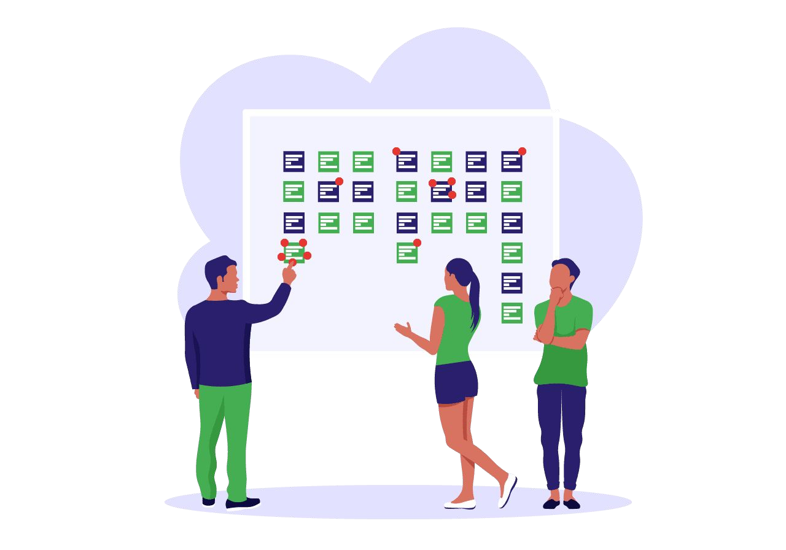

Affinity Mapping
Affinity mapping is a method to group similar tasks together so planning and estimation becomes easier.
Instead of estimating each task one by one, we first make groups, then estimate each group.
Simple idea:
“Put similar tasks in the same group, then estimate the group together.”
Example: Online Shopping App Project
We have different tasks:
- Designing login page
- Building product search feature
- Creating payment system
- Writing product database
- Testing the app
- Deploying the app
Now we make “groups” (Affinity Mapping)
1. UI / Frontend Group
Everything users see on screen
- Designing login page
- Product search feature
2. Backend / Database Group
- Data and server work
- Writing product database

3. Payment System Group
- Money-related work
- Creating payment system
4. Testing Group
Checking errors
- Testing the app
5. Deployment Group
Launching the app
- Deploying the app
Simple meaning:
Instead of estimating each task separately, we estimate:
- UI group
- Backend group
- Payment group
- Testing group
- Deployment group
Role of AI
- Automatically groups similar tasks → AI puts related tasks together
- Finds patterns → AI detects connections between tasks from past data

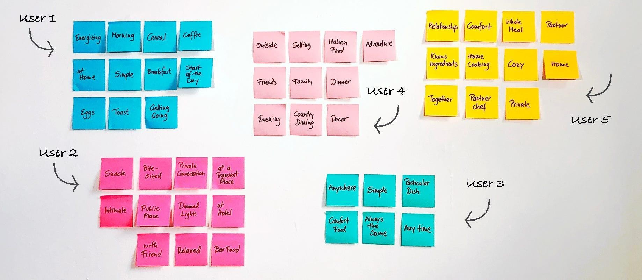
Bucket System
The bucket system is a quick way to estimate many tasks by sorting them into groups called “buckets.”
Each bucket represents a level of effort or difficulty.
Simple idea:
“Put tasks into boxes (buckets) based on how hard they are.”
How it works:
- Tasks are placed into different buckets (easy, medium, hard, etc.)
- The team discusses the placement
- Tasks can be moved between buckets if needed
- Finally, the team agrees on correct estimates

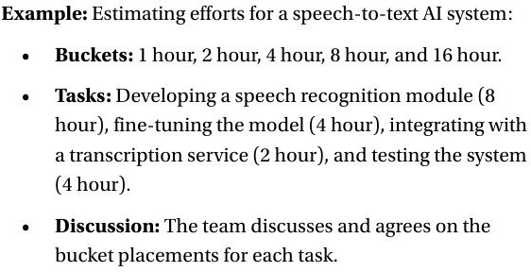
Three-Point Estimation
Three-point estimation is a method to predict how much effort or time a task will take by using three different cases.
Three values used:
- Optimistic (O) → best case (everything goes very smoothly)
- Most Likely (M) → normal case (what usually happens)
- Pessimistic (P) → worst case (delays or problems happen)
Simple idea:
“We don’t guess one number. We think about best, normal, and worst cases.”
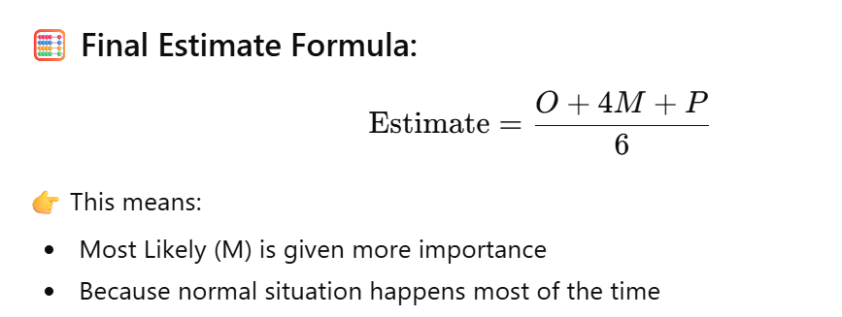
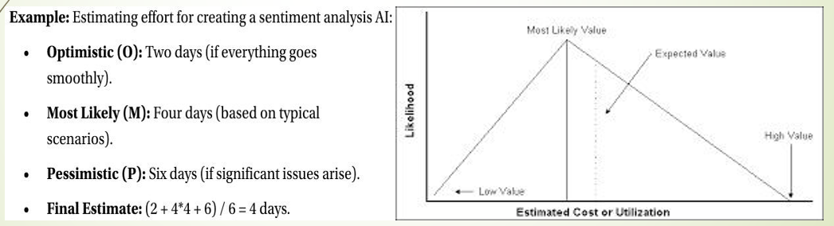
Use Case Points Estimation
Use Case Points estimation is a method used to estimate how much effort is needed to build a software system based on its use cases.
Simple idea:
“The more and more complex the use cases, the more effort is needed.”
It depends on:
- Number of use cases → how many features or functions the system has
- Complexity of actors → how users or external systems interact with the system (simple or complex interactions)
What is a use case?
A use case is just a feature or action a user performs in a system.
Example:
- Login
- Search product
- Make payment
Role of AI:
- Analyzes use case complexity → AI checks how hard each feature is
- Predicts effort automatically → AI estimates how much time and work is needed
NLP for Requirement Engineering
NLP (Natural Language Processing) is a technology that helps computers understand human language (like English). In software engineering, it is used to analyze and understand project requirements written by users or stakeholders.
Applications:
- Automatic requirement extraction → AI reads documents and picks out important requirements automatically
- Detecting ambiguous requirements → AI finds unclear or confusing statements in requirements
- Requirement classification → AI separates requirements into types like functional (what system does) and non-functional (performance, security, etc.)
- Analyzing stakeholder documents → AI reads emails, reports, and notes to understand what users want
Example:
AI tools like:
- ChatGPT / GPT-4
- ReQtest AI
- IBM Watson Natural Language Understanding (NLU)
- Google Cloud Natural Language API
can read:
emails, documents, and messages from stakeholders
and then:
- identify system requirements
- separate functional and non-functional needs
Automated Requirement Analysis
Automated Requirement Analysis means using AI tools to automatically check and understand software requirement documents.
What AI can do:
- Detect requirement inconsistencies → finds mistakes or mismatched requirements
- Identify missing requirements → shows what important details are not written
- Improve requirement traceability → connects requirements with design, code, and testing
- Automate documentation → helps create and organize requirement documents automatically
Example:
AI systems can detect problems like:
- Unclear requirements (not properly explained)
- Duplicate requirements (same thing written twice)
- Conflicting requirements (two statements that disagree with each other)
Tools used:
- Jama Connect
- Visure Requirements
- AI-powered Jira plugins

Lecture 5
Integrating Generative Ai in Software Design and Architecture
Good Software Design
A good software design means planning the structure of a software system in a clear and simple way before building it.
In easy words:
- It gives a clear direction to the development team, like a roadmap.
- It helps developers understand what exactly they need to build.
- The main goal is to build a working system with less confusion and complexity.
- To reduce complexity, the system is broken into small parts called components.
Each component has a small, specific job, which makes the system:
- easier to understand
- easier to develop
- easier to test
- easier to maintain
Now, about AI:
AI tools and Large Language Models (LLMs) can help software designers by:
- suggesting better system structures
- finding design problems early
- improving architecture ideas
- helping reduce complexity
So overall, good software design + AI support = a clearer, simpler, and more efficient system to build and maintain.
Continue …
A good software design allows parts of the system (components) to be reused again and again in different places.
This reuse saves time and effort, so development becomes faster and more efficient.
A strong design also includes automation tools.
Automation helps in testing and checking the system automatically.
Because of automation, problems can be found early, before they become big issues.
Finding issues early helps save time, money, and effort.
Good software design also makes the system:
- Flexible (easy to change)
- Scalable (can handle more users or data)
So, when new requirements come, the software can easily adapt without major changes.
Modular & Iterative Design
- Software should be built using modular design (separate modules)
- Modules can be independent but also connected when needed
- This helps teams to work together and in parallel
- Developers can integrate their work easily and smoothly
- Software design is not a one-time process
- It is an iterative process (continuous improvement)
- Design must be updated when new technology or requirements come
High-Level Design (HLD)
- Software design starts with requirement analysis
- Both stated and unstated needs of users are considered
- HLD gives a big picture (overall system structure)
- It decides the type of system (monolithic, microservices, etc.)
- It includes technology choices and design patterns
- HLD acts as a roadmap for development. It shows how components interact and how data flows
Low-Level Design (LLD)
- After HLD, we move to Low-Level Design (LLD)
- LLD focuses on detailed design of each component
- It defines internal structure of modules
- It includes algorithms and data structures
- It explains how components communicate via interfaces
- HLD ensures clear system architecture
- LLD ensures detailed implementation and logic
Design Principles
Design principles make software efficient and easy to maintain.
Modularity: Divide the system into small independent parts.
Abstraction: Hide complex details and show only simple interfaces.
Encapsulation: Keep internal data hidden from other modules.
Cohesion: Keep related functions together in one module.
Coupling: Reduce dependency between different modules.
Software Design Principles
1. Consider Alternative Approaches / Avoid Tunnel Vision
Don’t stick to only one idea. Before finalizing the design, always think about different ways to solve the problem.
Looking at multiple options helps you choose the best and most efficient design rather than just the first idea that comes to mind.
2. Traceability to Analysis Model
Your design should be linked to the analysis model, meaning every part of the design should come from the requirements gathered during analysis.
This makes sure that the design meets user needs and that nothing important is missed.
3. Don’t Reinvent the Wheel
Avoid creating things from scratch if a ready or tested solution already exists.
For example, use existing libraries, tools, or design patterns — this saves time, reduces errors, and makes the system more reliable
4. Minimize Intellectual Distance
Minimizing intellectual distance means that the software design should be as close as possible to the real-world problem it is solving. This means using real-world names and ideas that make sense to users.
For example, in a school management system, using words like “Student,” “Teacher,” and “Class” keeps the design simple and easy to understand.

5. Uniformity and Integration
A good software design should look and feel consistent throughout the system.
- It shows uniformity when the design seems like it was made by one person, even if a whole team worked on it.
- It is integrated when all parts of the system fit together smoothly, and the connections (interfaces) between them are well-defined and clear.
7. Review to Avoid Conceptual Errors
Designs should always be reviewed carefully to find and fix conceptual or meaning-related mistakes before moving to coding.
This ensures that the design correctly represents the intended system behavior and user requirements.
8. Design Is Not Coding and Coding is not design 7
Design and coding are not the same thing.
- Design is about planning and structure — deciding how the system will work.
- Coding is about implementing that plan using a programming language.
Even if the design goes into small details, it still stays at a higher level of abstraction than the actual source code.
9. Flexible for Change
The design should be made in a way that allows easy updates or changes in the future without breaking the whole system.
10. Graceful Degradation
Even if something unexpected happens (like wrong input or system error), the software should handle it smoothly instead of crashing.
11. Check Quality During Design
The design’s quality should be reviewed and improved while it’s being made, not only after it’s finished.
Software Design Components
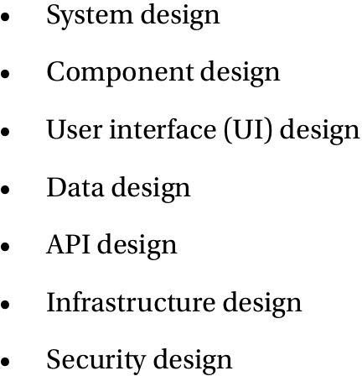

AI in Software Design
- AI tools can simulate different software architectures.
- AI helps predict system performance before deployment.
- It can suggest whether to use microservices or monolithic architecture.
- Microservices: small independent services.
- Monolithic: single large system with shared resources.
- AI explores multiple design options for better optimization.
- It improves performance, scalability, and reliability.
- Human validation is still required for final decisions.
AI in High-Level Design
- AI helps break a system into small, manageable parts.
- It can show how data flows between components.
- AI explains how data moves from frontend to backend.
- It helps find integration problems early.
- AI suggests improvements in system design.
- It makes system planning more accurate.
- But setting up AI tools can be complex.
- AI may not handle all real-world situations.
Ai Driven Tools for Software Designing
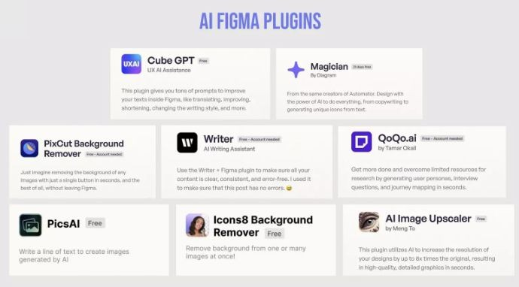
AI in Software Design & Development
- AI helps in automating software design tasks.
- Developers can use AI to generate code quickly.
- AI suggests better design patterns and structures.
- It improves development speed and productivity.
- AI reduces human errors in coding.
- It supports testing and debugging processes.
- AI makes software development more efficient and reliable.
Object-Oriented Programming (OOP)
- OOP is a programming style based on objects and classes.
- It helps organize code in a structured way.
- Main concepts are: Encapsulation, Inheritance, Polymorphism.
- It supports code reuse and modularity.
- It makes large systems easy to manage and maintain.
- AI can help suggest better class design and relationships.
- Common OOP languages are: Java, Python, C++.
Functional Programming in Modern Development
- Functional programming focuses on functions instead of objects.
- It avoids changing data, so code becomes more predictable and easier to test.
- It uses pure functions (same input → same output).
- It helps in building parallel and scalable systems.
- AI can help optimize functional programming patterns.
- It is commonly used in data processing and AI systems.

AI-Driven Design Patterns
- Design patterns are reusable solutions to common problems
- AI can recommend best patterns based on requirements
- It helps choose between different architectures
- AI improves code quality and maintainability
- Examples: MVC, Microservices, Singleton
- AI can analyze code and suggest pattern improvements
- This leads to better structured applications
Code Architectures with AI
- AI helps design efficient system architectures.
- It suggests whether to use monolithic or microservices approach.
- AI can simulate system performance before implementation.
- It helps build scalable and flexible systems.
- It improves data flow and module interaction design.
- AI reduces design errors in early stages of development.
- It supports faster decision-making for system architects.
Generative AI for Code Generation
- Generative AI can automatically write code.
- It helps developers save time and effort.
- It can generate functions, classes, and full modules.
- It supports multiple languages like Python, Java, and JavaScript.
- It helps beginners learn coding faster.
- It reduces repetitive coding tasks.
- It needs human review to ensure accuracy and quality.

AI for Refactoring
- Refactoring means improving code without changing its functionality.
- AI can detect bad coding practices (code smells).
- It suggests cleaner and more optimized code structure.
- It improves readability and maintainability.
- It helps remove duplicate or unnecessary code.
- It makes code easier to update in the future.
- It can also improve overall performance.
AI for Debugging and Testing
- AI helps in finding bugs quickly.
- It can analyze code and detect errors automatically.
- It suggests possible fixes for bugs.
- It helps in automated testing (like unit testing).
- It improves software reliability and quality.
- It saves time compared to manual debugging.
- AI-based code analysis tools are used for this purpose.
Generative AI for Architecture Prototyping
- AI helps create early prototypes of system architecture.
- Developers can test ideas before full development.
- AI suggests different design options.
- It helps in visualizing system structure.
- It reduces the risk of wrong design decisions.
- It speeds up the planning phase of projects.
- It still needs human review and customization.

